**Project Outline: Stock Market Prediction Using Stacked LSTM  
Mukul Sagar**  
  
**Problem Statement:**  
Accurately forecasting stock market movements is crucial for investors seeking to optimize returns. However, the inherent complexity and volatility of financial markets pose significant challenges to traditional forecasting methods. To address this, advanced techniques leveraging deep learning models are increasingly being employed. This project aims to harness the power of stacked Long Short-Term Memory (LSTM) neural networks, augmented with Dense layers and structured in a Sequential model, to predict stock market prices with precision and reliability.  
  
**Project Description:**  
This data science project delves into the implementation of stacked LSTM neural networks, complemented by Dense layers organized in a Sequential model, for stock market prediction using Python. By integrating these components, we create a sophisticated predictive model capable of capturing intricate temporal dependencies within historical stock market data. Leveraging Python programming and deep learning methodologies, the project endeavors to develop a robust predictive framework that empowers investors with actionable insights for informed decision-making.  
  
**Methodology:**  
1. **Data Preprocessing:**  
 - Utilize essential libraries such as `numpy`, `pandas`, `matplotlib`, and `seaborn`.  
 - Normalize the raw data using MinMaxScaler to ensure consistent scaling within the range [0, 1].  
 - Partition the dataset into training and testing subsets, allocating 65% of the data for training purposes.  
  
2. **Model Architecture:**  
 - Construct a Sequential model using the TensorFlow Keras API to orchestrate the neural network architecture.  
 - Configure stacked LSTM layers to capture intricate temporal dependencies present in sequential data.  
 - Integrate Dense layers to facilitate feature extraction and mapping.  
 - Compile the model utilizing the mean squared error loss function and the Adam optimizer for efficient training.  
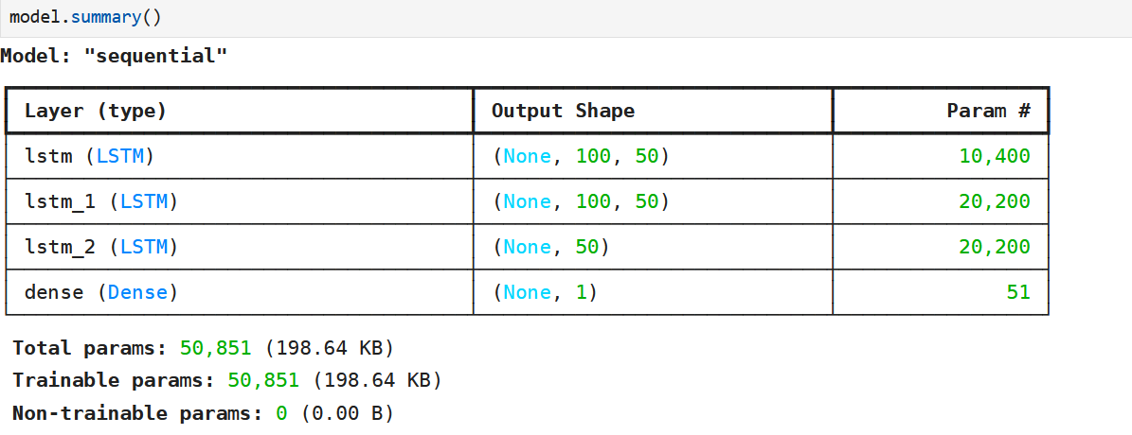  
3. **Model Training and Evaluation:**  
 - Train the model using the training data, specifying 100 epochs and a batch size of 64.  
 - Validate the model's performance on the testing data to assess its generalization capabilities.  
 - Evaluate the model's accuracy using the root mean squared error (RMSE) metric, yielding values of 366.75 for the training dataset and 564.96 for the testing dataset.

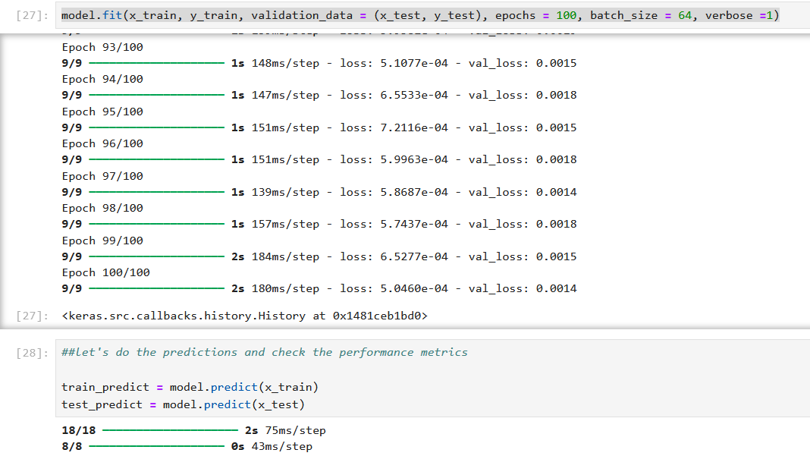4. **Prediction:**  
 - Employ the trained model to predict stock prices for the subsequent 30 days.  
 - Illustrate the prediction process by iteratively forecasting future prices based on historical data.  
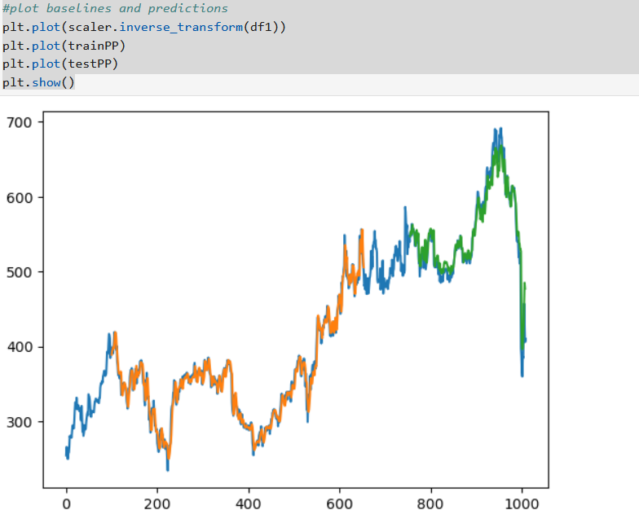  
5. **Visualization and Analysis:**  
 - Visualize the predicted stock prices alongside the actual values using matplotlib.  
 - Analyze the plotted data to discern patterns, trends, and potential areas for model refinement.  
 - Leverage insights gained from visualization to iteratively optimize the model architecture and parameters for enhanced predictive performance.

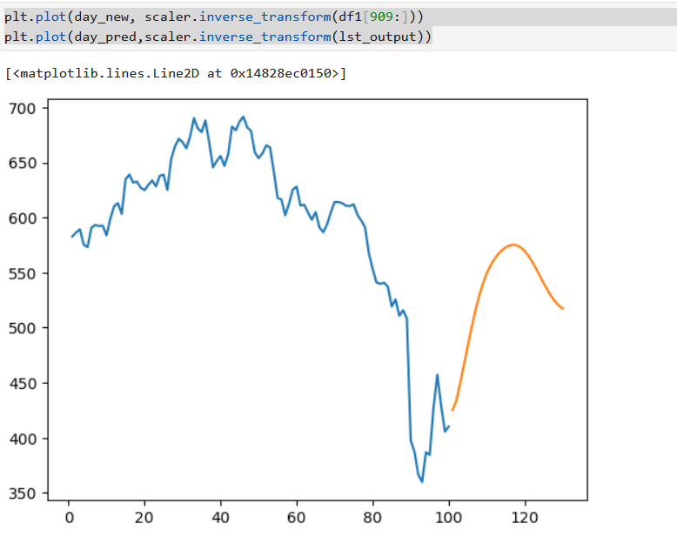  
**Conclusion:**  
By leveraging stacked LSTM neural networks, Dense layers, and a Sequential model architecture, this project advances the frontier of stock market prediction using deep learning techniques in Python. The rigorous evaluation of the model, as evidenced by the RMSE values, underscores its efficacy in capturing and forecasting complex stock market dynamics. Through visualization and analysis, stakeholders can gain actionable insights into market trends, enabling informed investment decisions. Continued refinement and optimization of the model hold promise for further enhancing its predictive capabilities and contributing to more accurate stock market predictions.